Practicum Final Exam – Even Semester Year 2021/2022
Subject |  |  | COMP6048 – Data Structures  COMP6048001 – Data Structures  COMP6048016 – Data Structures  COMP6048049 – Data Structures |  |  | 
Class | : | BQ01 / BR01 / BY01 / BZ01 |  | Start Date | : 18 June 2022
Lecturer | : | D4456 – Dennise Adrianto, S.Kom., M.T.I.  D4833 – Muhammad Danaparamita, S.Kom., M.T.I |  | Start Time | : 15.20
Lecturer | : |  |  | End Date | : 18 June 2022
Lecturer | : |  |  | End Time | : 17.20

PERATURAN UJIAN:
Exam Regulations:
- Mahasiswa tidak diperbolehkan berdiskusi dan/atau bekerja sama dengan peserta ujian lainnya
Student is not allowed to discuss and/or work together with other exam participants
- Mahasiswa tidak diperbolehkan untuk membuka dan menyalin dari BUKU atau CATATAN, VIDEO dari pengajar (recording kelas, VBL, Youtube, dsb) dan REFERENSI lainnya
Student isn't allowed to open and copy from any resources such as notes, videos (class recording, VBL, Youtube, etc) and other references
- Mahasiswa tidak diperbolehkan membuka dan menyalin jawaban dari internet (google, stackoverflow, dsb)
Student isn't allowed to open and copy answer from the internet (google, stackoverflow, etc)
- Asisten BERHAK memberi nilai 0 (NOL) bagi peserta ujian yang melakukan segala bentuk kecurangan
Assistant is able to give 0 (ZERO) score for exam participant who does any cheating actions
- Kumpulkan jawaban tepat pada waktunya, apabila terlambat mengumpulkan maka jawaban tidak akan dikoreksi dan nilai mahasiswa adalah 0
Submit the answer on time, if not, then the answer will not be checked, and the students will receive 0 (ZERO)
- Bila Anda tidak membaca peraturan ini, maka Anda dianggap telah membaca dan menyetujuinya
If you have missed to read these regulations, so you are considered to have read and agreed on it



SOFTWARE YANG DIGUNAKAN:
Software will be used:
- Dev-C++ 5.11

FILE YANG DIKUMPULKAN:
File must be collected:
- CPP

PERHATIAN!
Attention!
- Bagi yang mengerjakan tidak sesuai dengan soal, maka akan diberikan nilai NOL (0)
For those who do not work in accordance with the exam case will be marked as ZERO (0)
- Bagi yang mengerjakan tidak sesuai dengan software dan versi yang telah ditetapkan, maka akan tetap dikoreksi dengan software dan versi yang telah ditetapkan
For those who do not work in accordance with the software and specific version will be corrected by the predefined software and version
- Kompres semua jawaban yang akan diunggah. Pastikan format pengumpulan nama file dan ekstensi sesuai dengan format berikut: [NIM]-[NAMA].zip
Compress all file that will be uploaded. Make sure the format for collecting file name and extension according to the following format: [NIM]-[NAME].zip

Soal
Case
AmaSUn
AmaSUn is an application used to manage stores. Given many stores come and go, making harder to track manually, the owner of AmaSUn, Ms. Susan decides to hire you, a programmer to create an application using AVL Tree as its base algorithm. You are to create an application based on the following requirements :
- At the start of the program, there will be 5 menus, which consists of :
- View all stores
- Insert new store
- Delete a store
- Delete all stores
- Exit
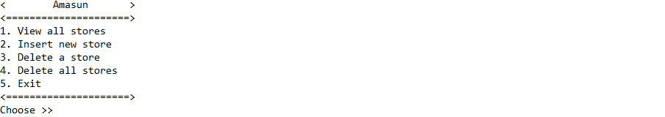
Figure 1. main menu
- If user choose menu 1 (View all stores), the program will :
- Check data from AVL Tree. If there are no data, display following message
Figure 2. no data message
- Otherwise,
- Display view sub-menu
- Prompt user to input View Input. Validate the input must be between 1 and 3
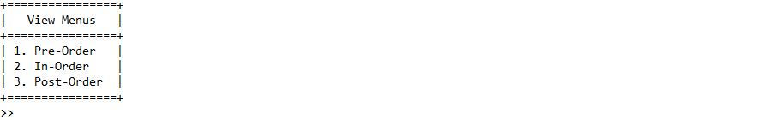
Figure 3. view sub-menu input
- If View Input is 1, display all data in pre-order format
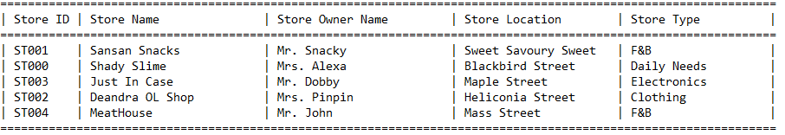
Figure 4. view data in pre-order format
- If View Input is 2, display all data in in-order format
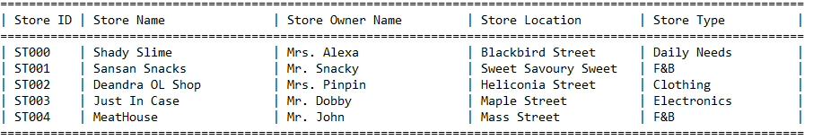
Figure 5. view data in in-order format
- If View Input is 3, display all data in post-order format
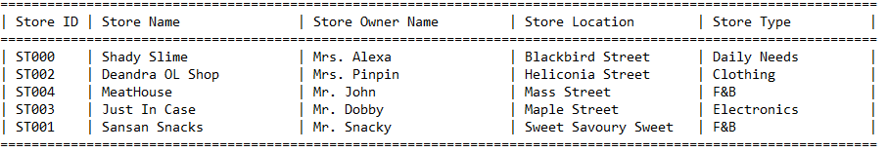
Figure 6. view data in post-order format
- If user choose menu 2 (Insert new store), the program will :
- Prompt user to input Store Name. Validate the input must be 5 characters minimum
- Prompt user to input Store Owner. Validate the input must starts with “Mr. ” or “Mrs. ” (case sensitive)
- Prompt user to input Store Location. Validate the input must ends with “ Street” (case sensitive with leading space)
- Prompt user to input Store Type. Validate the input must be between “Daily Needs”, “Clothing”, “F&B”, “Electronics”, and “Kitchenware” (case insensitive)
- Generate Store ID based on following formula :
STXXX
XXX : number of store index increment by 1
Note : first store always start with 0-th index, their id will be ST000
- Finally, create a node and push unto AVL Tree with Store ID as its key
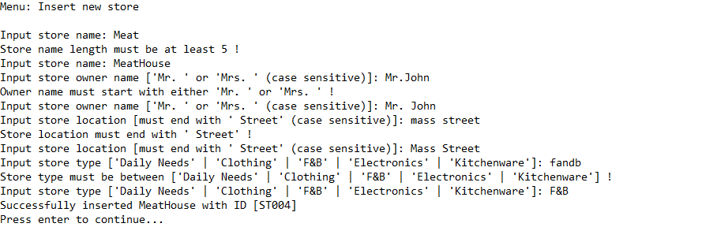
Figure 7. insert store data input
- If user choose menu 3 (Delete a store), the program will :
- Check data from AVL Tree. If there are no data, display following message
Figure 8. no data message
- Otherwise,
- Display all data in in-order format
- Prompt user to input Store ID
Figure 9. deletion store input
- Check data from AVL Tree based on input
- If data not exists, display following message
Figure 10. searched data not exists
- Otherwise, remove data from AVL Tree and display following message
Figure 11. successfully delete data message
- If user choose menu 4 (Delete all stores), the program will :
- Check data from AVL Tree. If there are no data, display following message
Figure 12. no data message
- Otherwise,
- Prompt user to input Delete Confirmation. Validate the input must be between “Yes” and “No” (case sensitive)
Figure 13. delete all input
- If Delete Confirmation is “Yes”, then remove all data from AVL Tree and display following message
Figure 14. successfully delete all data message
- Otherwise, redirect to main menu
- If user choose menu 5 (Exit), the program will close

